Requirement Clarification

Whether a patient can have many appointments with different doctors?
Can 1 appointment involve multiple diagnose and treatment?
Can a consultation have multiple medicine?
Whether each consultation give different bill?
1 bill have multiple payments?
Are medicines reused across different patients?
Can a patient be admitted to multiple rooms over time?
Are follow-ups linked to previous consultations?
Can multiple doctors be involved in one consultation?

Patient
Attributes:
patient id(pk)
patient name
patient phone

Department
Attributes:
department id(pk)
department name

Doctor
Attributes:
Doctor id(pk)
doctor name
Specialization
department id(fk)

Appointment
Attributes:
Appointment id(pk)
patient id(fk)
appointment datetime

Consultation
Attributes:
Consultation id(pk)
appointment id(fk)
notes

Consultation Doctor
Attributes:
Consultation id
doctor id
role

Diagnosis
Attributes:
Diagnosis id(pk)
consultation id(fk)
diagnosis text

Medicine
Attributes:
Medicine id(pk)
medicine name
price

Prescription
Attributes:
Prescription id(pk)
consultation id(fk)
medicine id(fk)
dosage, duration

Billing
Attributes:
Bill id(pk)
consultation id(fk)
total amount

Payment
Attributes:
Payment id (pk)
bill id(fk)
amount paid
payment date

Normalization
1NF
All attributes are atomic and contain single values.There are no repeating groups or multi-valued attributes.Like
Medicines are stored in a separate medicine table
Multiple medicines are handled using the prescription table

2NF
The schema is in 1NF and there are no partial dependencies.All non-key attributes fully depend on their pk
Doctor details are stored in the doctor table
Appointment contains only attributes related to appointment

3NF
The schema is in 2NF and there are no transitive dependencies.
Department details are separated into thedepartment table
Doctor references department using department id

Queries

1. Identify the doctor who has handled the highest number of consultations. (Must use aggregation and joins)

SELECT
d.doctor_id,
d.doctor_name,
COUNT(cd.consultation_id) AS total_consultations
FROM Doctor d
JOIN Consultation_Doctor cd ON d.doctor_id = cd.doctor_id
GROUP BY d.doctor_id, d.doctor_name
ORDER BY total_consultations DESC;
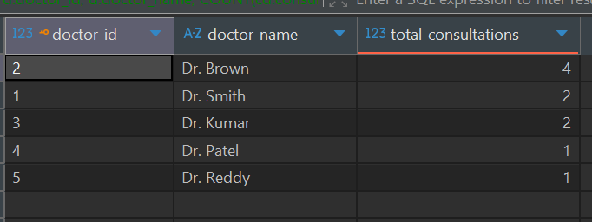

2. List all patients who have pending payments along with total outstanding amount.
SELECT
p.patient_name,
SUM(b.total_amount - IFNULL(pay.amount_paid, 0)) AS pending
FROM Patient p
JOIN Appointment a ON p.patient_id = a.patient_id
JOIN Consultation c ON a.appointment_id = c.appointment_id
JOIN Billing b ON c.consultation_id = b.consultation_id
LEFT JOIN Payment pay ON b.bill_id = pay.bill_id
GROUP BY p.patient_name
HAVING SUM(b.total_amount - IFNULL(pay.amount_paid, 0)) > 0;

3. Retrieve the complete consultation history of a patient, including doctors consulted, diagnoses, and prescribed medicines
SELECT p.patient_name, d.doctor_name, m.medicine_name
FROM Patient p
JOIN Appointment a ON p.patient_id=a.patient_id
JOIN Consultation c ON a.appointment_id=c.appointment_id
JOIN Consultation_Doctor cd ON c.consultation_id=cd.consultation_id
JOIN Doctor d ON cd.doctor_id=d.doctor_id
LEFT JOIN Prescription pr ON c.consultation_id=pr.consultation_id
LEFT JOIN Medicine m ON pr.medicine_id=m.medicine_id;

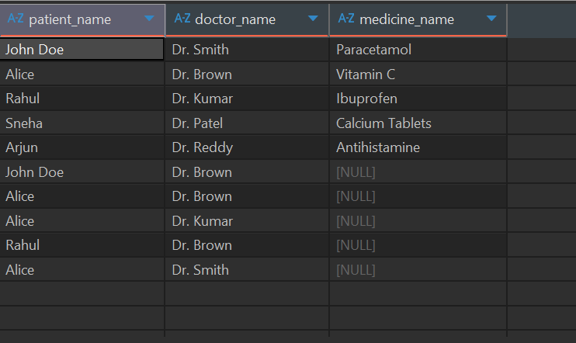
ER DIAGRAM

